**Helm and Kustomize**

Orchestrating your Deployments to Kubernetes

**Session Labs: Revision 1.1 - 11/03/20**

**Brent Laster**

**Important Note:** Prior to starting with this document, you should have the ova file for the class (the virtual machine) already loaded into Virtual Box and have ensured that it is startable. See the setup doc helm-setup.pdf in <http://github.com/brentlaster/safaridocs> for instructions and other things to be aware of.

**Lab 1: Repos and Charts**

**Purpose:** In this lab, we'll start working with Helm pulling down a Helm chart, examining it, and then installing it.

1. First, let's look at what repositories we have available to our local helm instance. **Open a terminal** **emulator** and enter

$ helm repo list

1. We have a local repository available via the ChartMuseum application that is already setup and running on your VM. There is a chart in there for our sample application named "roar-helm". Let's see what we can find out about it.

$ helm search repo roar-helm

$ helm show chart local/roar-helm

1. Now let's pull a copy of the chart down to look at the file structure. Change into the directory for the workshop, pull a copy and look at the structure.

$ cd hk-ws

$ helm pull --untar local/roar-helm

$ cd roar-helm

$ tree

You can further look at individual files if you want.

1. Now let's install a release of roar-helm in our local Kubernetes. We'll need to first create a namespace and then install the release. We also need to give it a name when we install. (The Kubernetes command line application, kubectl, is aliased to “k” on this machine.)

$ k create ns roar

$ helm install -n roar roar .

1. Take a look at the release that has been installed in the cluster.

$ helm list -n roar

You should see output like the following:

*﻿ ﻿NAME NAMESPACE REVISION UPDATED STATUS CHART APP VERSION*

*roar roar 1 2020-06-03 22:23:59.206949569 -0400 EDT deployed roar-web-0.1.0*

1. Now take a look at the resources that are installed in the cluster.

$ k get all -n roar

1. Find the nodeport where the app is running and open it up in a browser.

$ k get svc -n roar

Look for the NodePort setting in the service output (should be a number > 30000 after "8089:")

1. Open up a browser and go to [http://localhost:<NodePort>/roar/](http://localhost:%3cNodePort%3e/roar/)

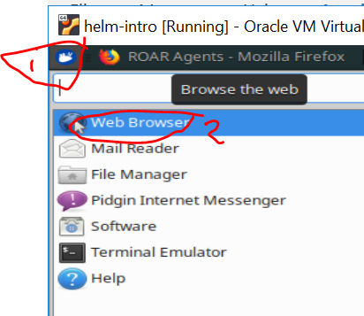

You should see something like this:

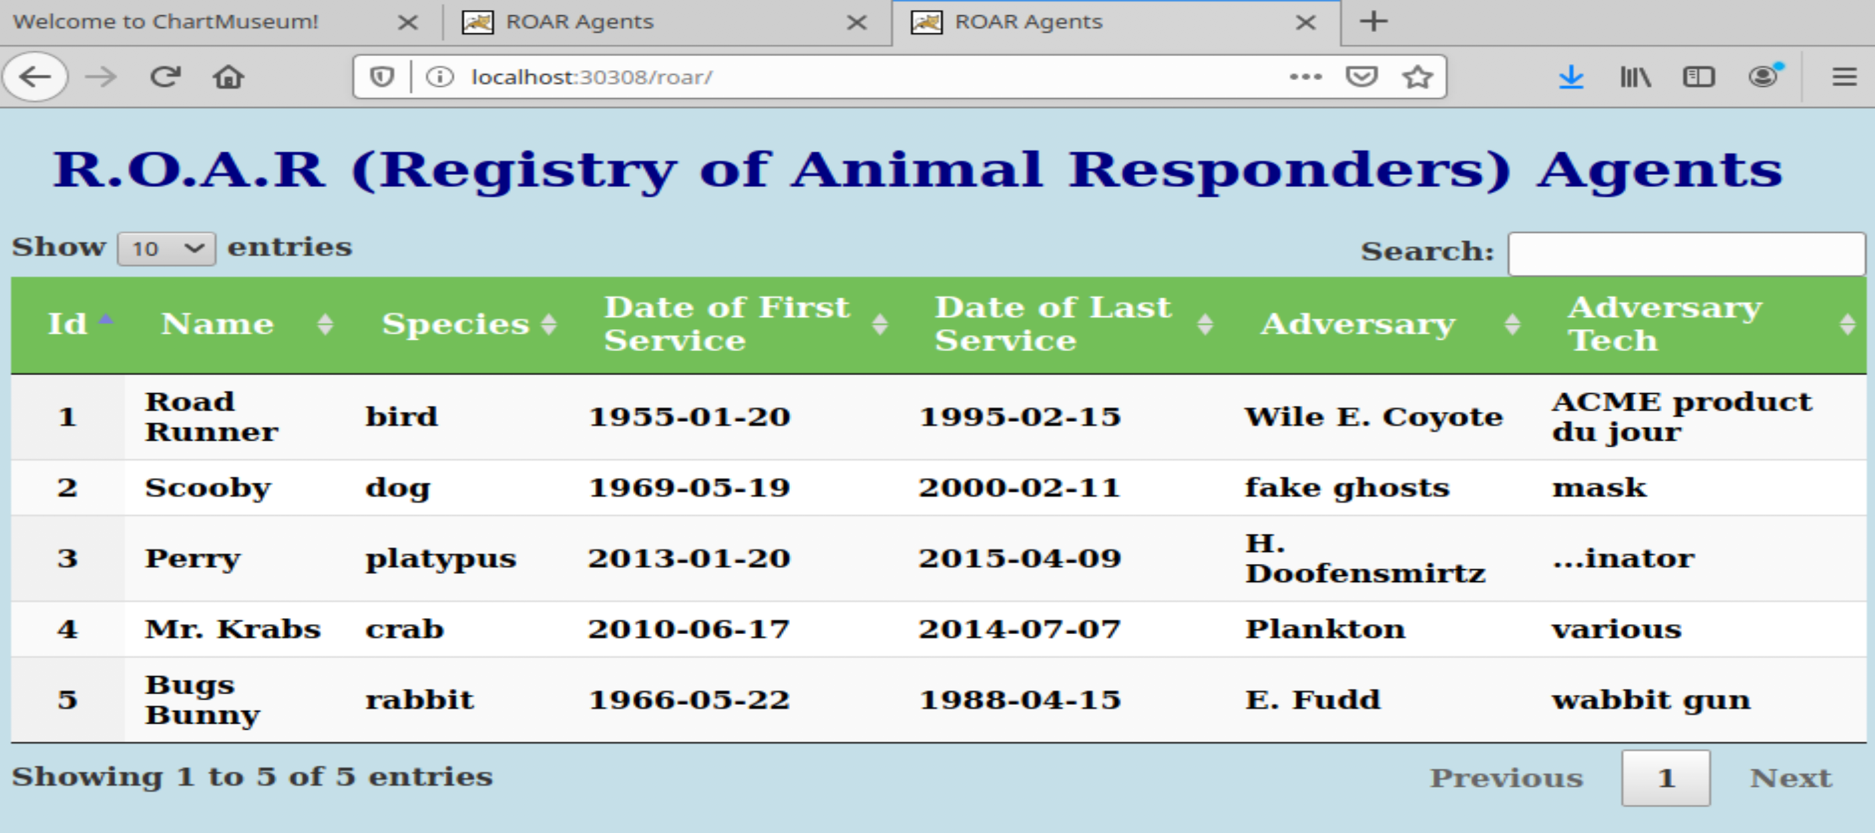

**Lab 2: Templating with Helm**

**Purpose:** In this lab, you’ll get to see how we can change hard-coded values into templates, override values, and and upgrade releases through Helm.

1. Take a look at the deployment template in the roar-helm directory and notice what the "image" value is set to. In *hk-ws/roar-helm*:

$ cat charts/roar-db/templates/deployment.yaml

Notice that the value for image is hardcoded to "*bclaster/roar-db-image:v1*".

1. We are going to change this to use the Helm templating facility. This means we'll change this value in the deployment.yaml file to have "placeholders". And we will put the default values we want to have in the values.yaml file. You can choose to edit the deployment file with the "gedit" editor. Or you can use the "meld" tool to add the differences from a file that already has them. If using the meld tool, select the left arrow to add the changes from the second file into the deployment.yaml file. Then save the changes.

Either do:

$ gedit charts/roar-db/templates/deployment.yaml

And change

*image: bclaster/roar-db-image:v1*

To

*image: "{{ .Values.image.repository }}:{{ .Values.image.tag }}"*

Or:

$ meld charts/roar-db/templates/deployment.yaml ../extra/lab2-deployment.yaml

Then click on the arrow circled in red in the figure. This will update the template file with the change. Then Save your changes and exit meld.

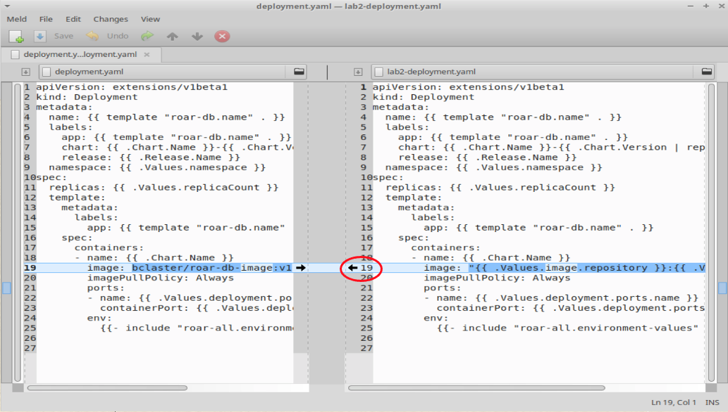

1. Now that we've updated the deployment template, we need to add default values. We'll use the same approach as in the previous step to add defaults for the *image.repository* and *image.tag* values in the chart's *values.yaml* file.

Either do:

$ gedit charts/roar-db/values.yaml

And add to the top of the file:

*image:*

*repository: bclaster/roar-db-image*

*tag: v1*

Or:

$ meld charts/roar-db/values.yaml ../extra/lab2-values.yaml

Then click on the arrow circled in red in the figure. This will update the values file with the change. Then Save your changes and exit meld.

1. Run a lint check on your updated chart files.

$ helm lint

1. Uninstall the existing release.

$ helm uninstall -n roar roar

1. Now let's install the updated release.

$ helm install -n roar roar .

1. Find the nodeport where the app is running and open it up in a browser.

$ k get svc -n roar

Look for the NodePort setting in the service output (should be a number > 30000 after "8089:")

1. Open up a browser and go to [http://localhost:<NodePort>/roar/](http://localhost:%3cNodePort%3e/roar/)

You should see the same webapp and data as before.

1. Now let's see how to override values from the helm command line. We'll do an upgrade and pass in a new image value that is for a "test version" of the database.

$ ﻿ helm upgrade -n roar roar . --recreate-pods

--set roar-db.image.repository=bclaster/roar-db-test,roar-db.image.tag=v4

1. Refresh the browser and you should see the test data showing up as in the picture below.

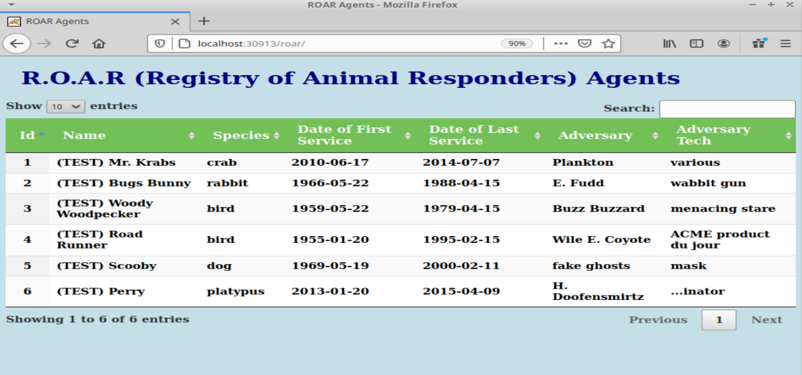

**Lab 3: Using Functions and Pipelines**

**Purpose:** In this lab, we'll see how to use functions and pipelines to expand what we can do in Helm charts.

1. In our last lab, we saw how to overwrite our production database with a test database via a command line option. But what if we want to build this option into the chart?

For switching between the prod and test database, we'll add two different versions of the image to choose from - one for prod and one for test. We'll also add a condition to report a failure if we don't have a valid entry passed.

Edit and modify the *charts/roar-db/values.yaml* file and update as indicated below or use the meld command for a simpler experience.

Either do:

$ gedit charts/roar-db/values.yaml

And replace these lines

image:

repository: bclaster/roar-db-image

tag: v1

with the following lines

﻿**image:**

**prod:**

**repository: bclaster/roar-db-image**

**tag: v1**

**test:**

**repository: bclaster/roar-db-test**

**tag: v4**

(See screenshot below and pay attention to the spaces and alignment.)

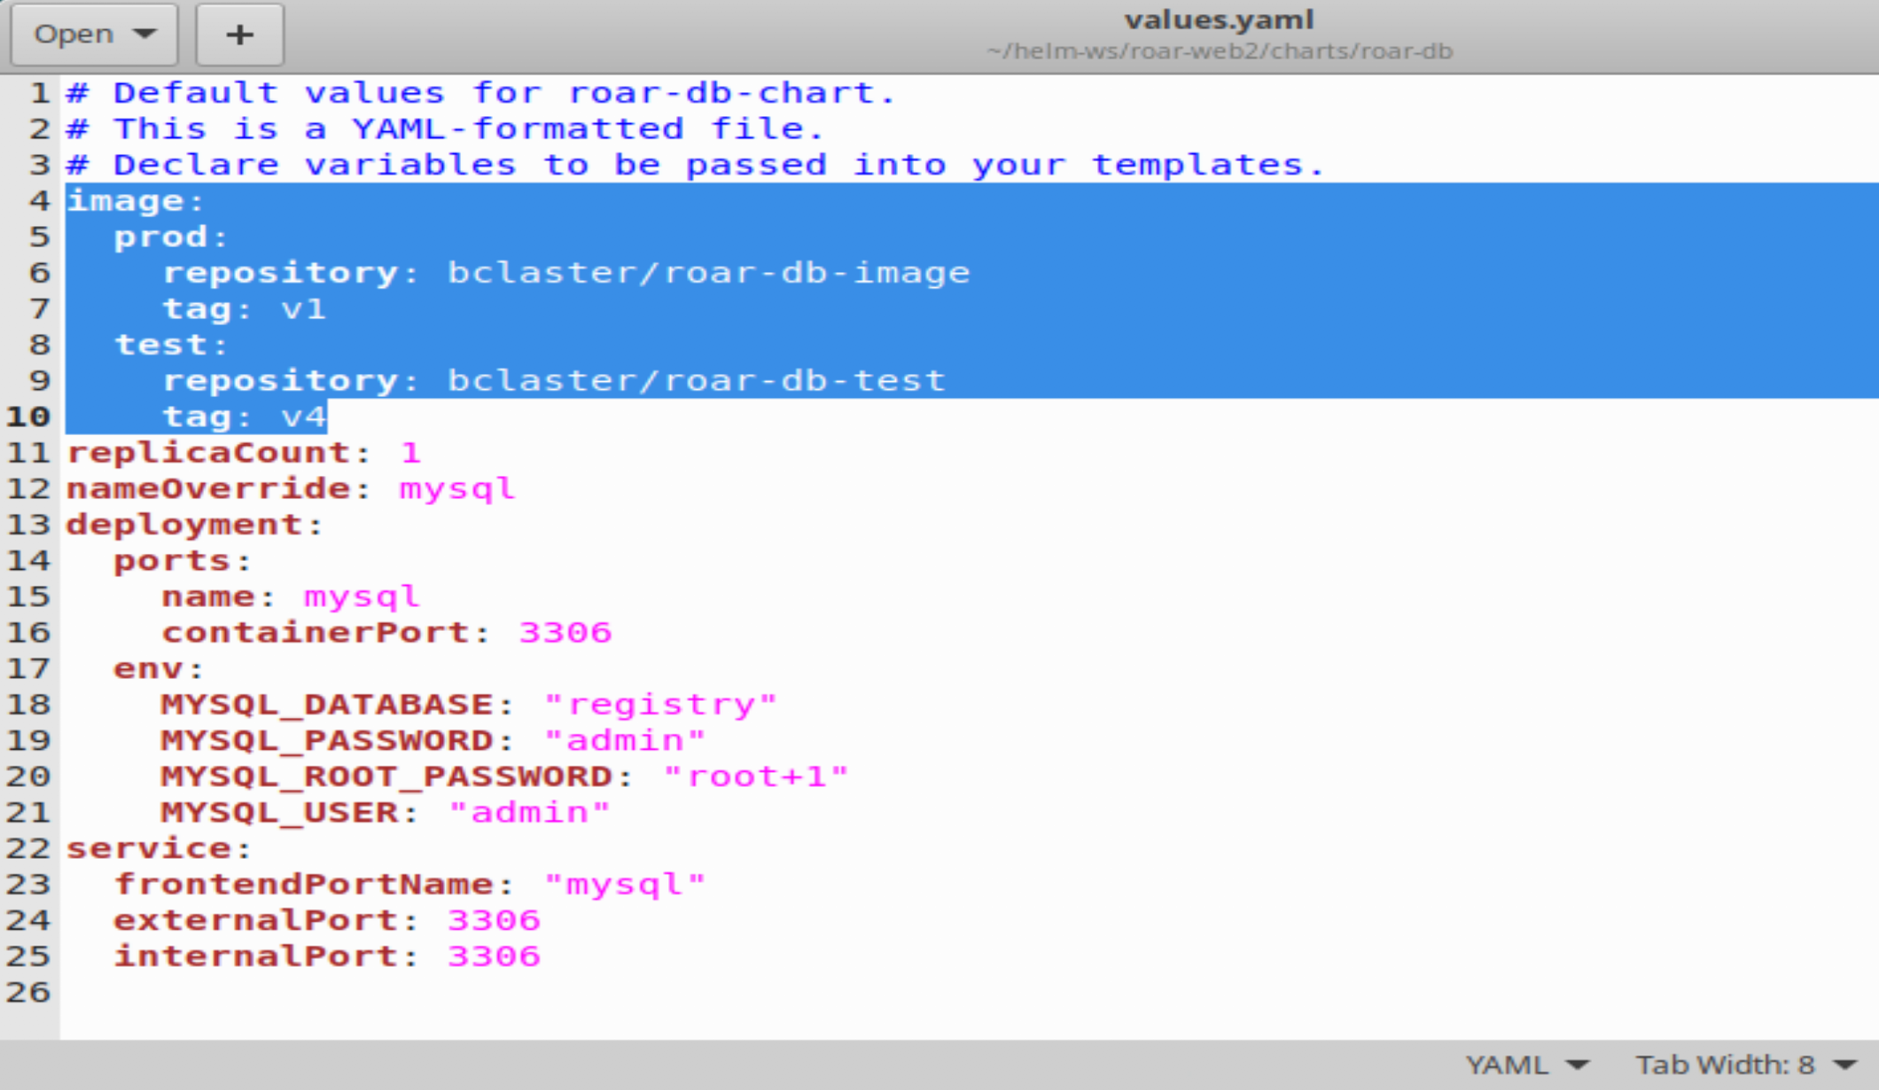

Or:

$ meld charts/roar-db/values.yaml ../extra/lab3-values.yaml

Then click on the arrow circled in red in the figure. This will update the values file with the change. Then Save your changes and exit meld.

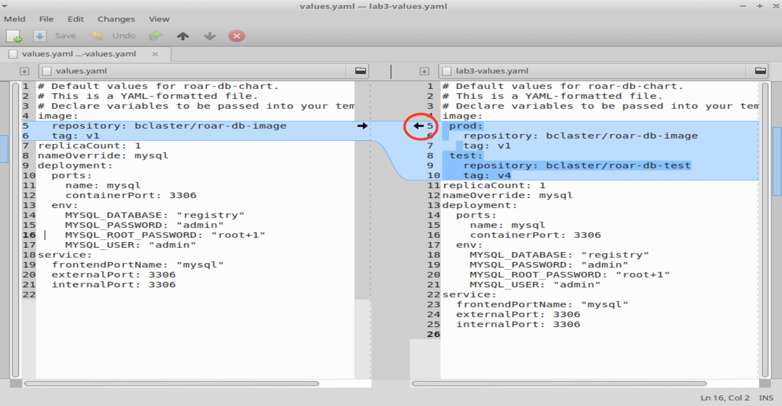

1. Now, we'll add some processing to enable selecting one of these images based on passing a setting for "stage" of either "PROD" or "TEST". The design logic (not what we actually add) is

*if stage = PROD*

*use image.prod.repository : image.prod.tag*

*else if stage = TEST*

*use image.test.repository : image.test.tag*

*else*

*display error message that we don't have a valid stage setting*

Translating this into templating syntax, we use an if/(else if)/else flow. The "eq" function is used for comparison, passing the two things to compare after it. Also, there is a "required" function that will handle the default error checking. Putting it all together, it could look like this:

**{{- if eq .Values.stage "PROD" }}**

**image: "{{- .Values.image.prod.repository }}:{{ .Values.image.prod.tag -}}"**

**{{ else if eq .Values.stage "TEST" }}**

**image: "{{- .Values.image.test.repository }}:{{ .Values.image.test.tag -}}"**

**{{ else }}**

**image: "{{- fail "A valid .Values.stage entry required!" }}"**

**{{ end -}}**

1. In the ~/hk-ws/roar-helm directory, edit the *charts/roar-db/templates/deployment.yaml* file and replace line 19 with the code from above in the containers section (see screenshot below). Pay attention to indentation and use spaces not tabs. Or use the meld command further down for a simpler experience:

$ gedit charts/roar-db/templates/deployment.yaml

<replace the existing image line with the lines from step 2>

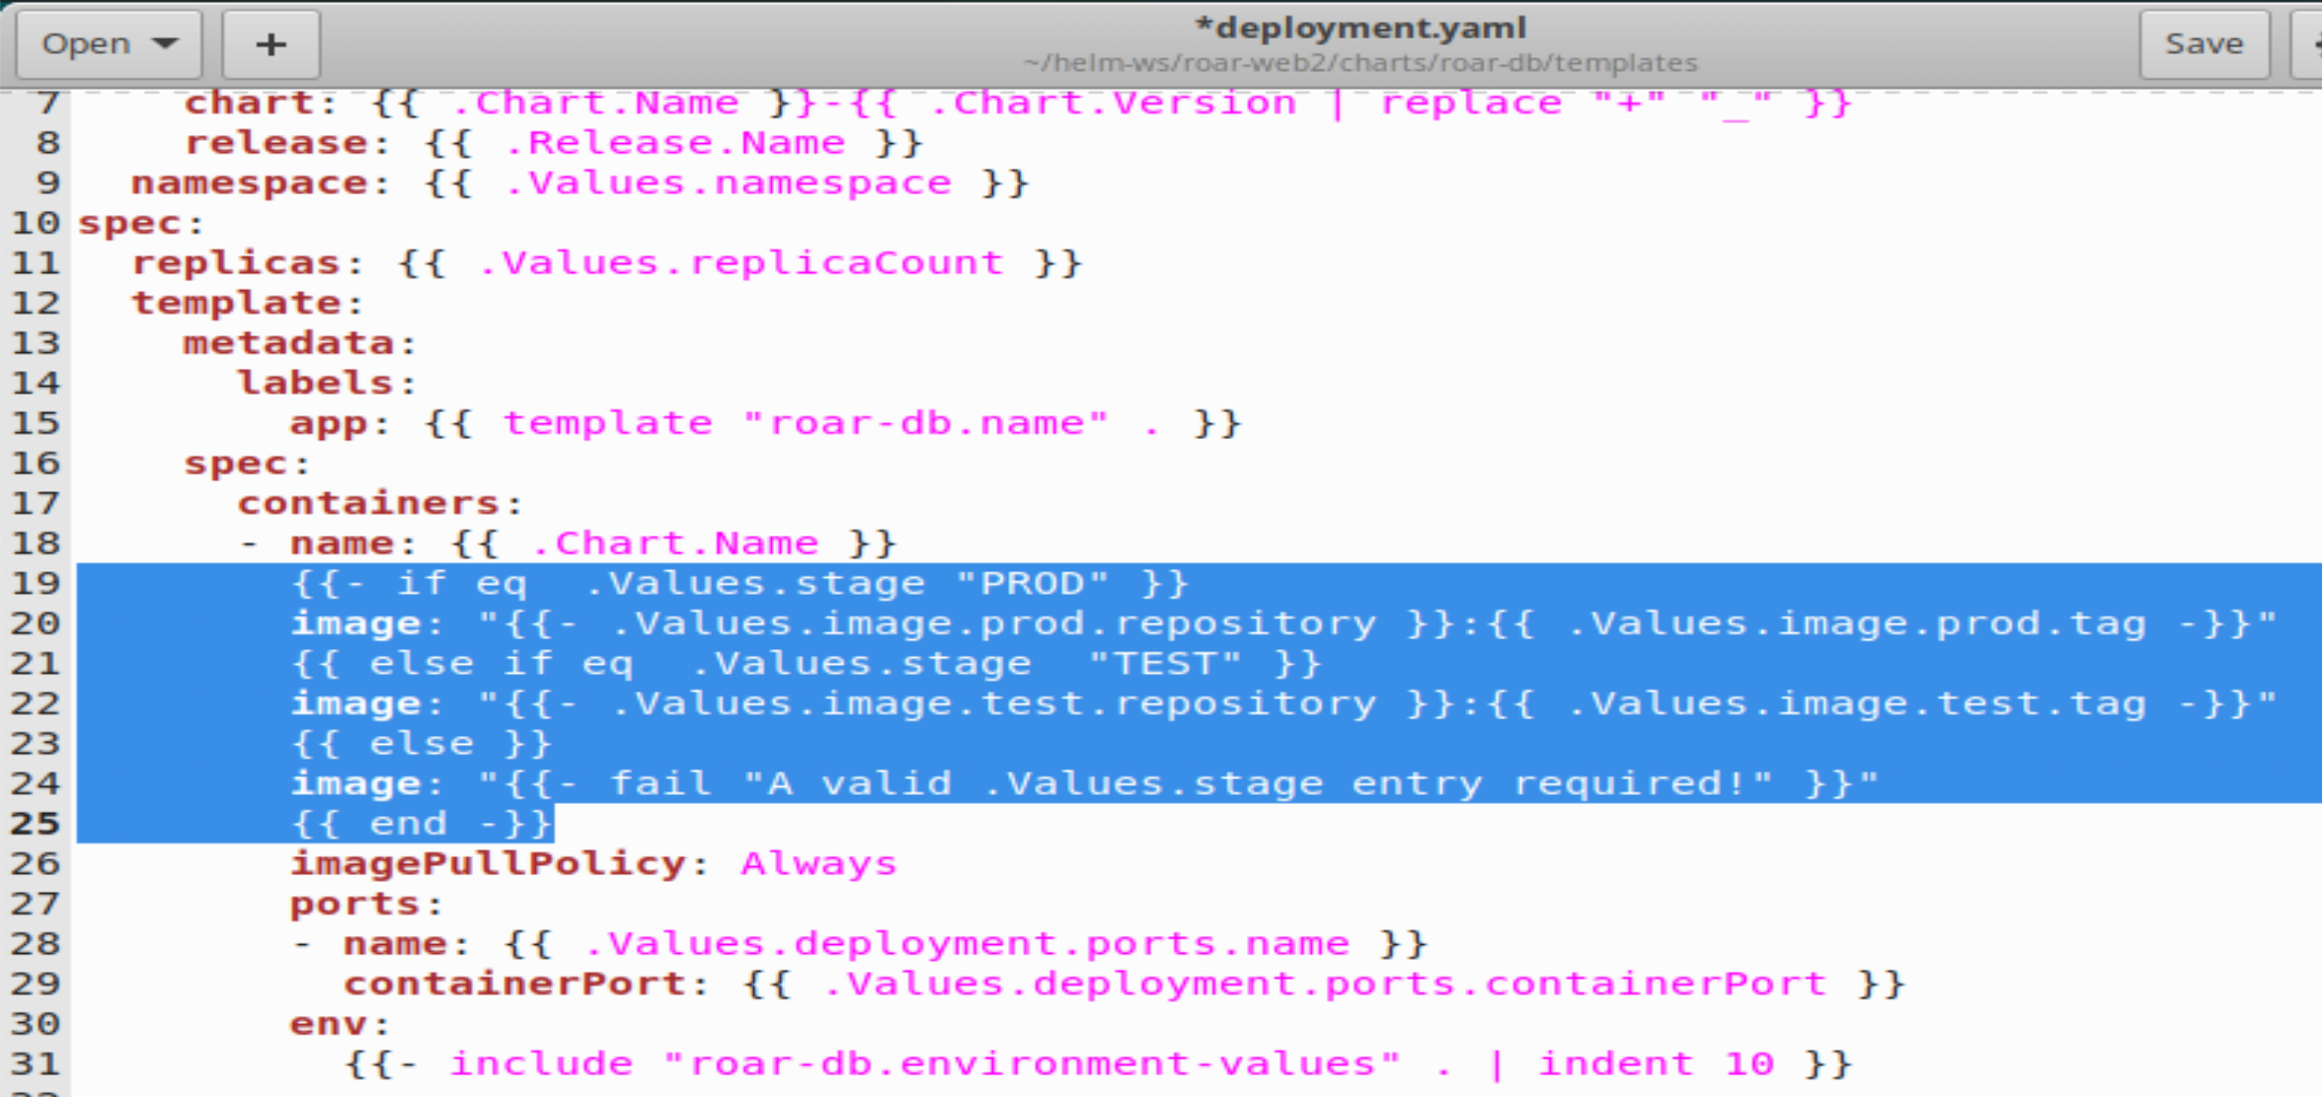

Or

$ ﻿meld charts/roar-db/templates/deployment.yaml ../extra/lab3-deployment.yaml

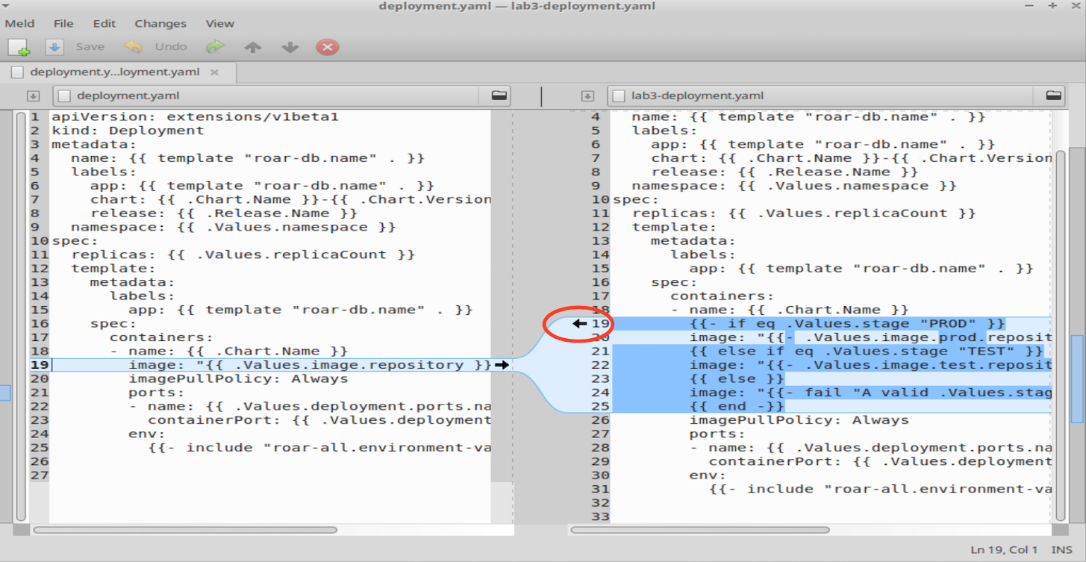

1. Save your changes and do a dry-run to make sure the image comes out as expected. To simplify seeing the change, we'll grep for image with a few lines of context.

$ helm install --set roar-db.stage=TEST --dry-run FOO . | grep image -n3

You should see output like the following:

﻿*65- spec:*

*66- containers:*

*67- - name: roar-db*

***68: image: "bclaster/roar-db-test:v4"***

*69: imagePullPolicy: Always*

*70- ports:*

*71- - name: mysql*

*72- containerPort: 3306*

*--*

1. While this appears to work, what happens if we pass a lower-case value?

$ helm install --set roar-db.stage=test --dry-run FOO . | grep image -n3

Notice we get the error message saying we don’t have a valid .Values.stage value (as we might expect).

﻿

1. This is not what we want. Let's make our arguments case-insensitive. To do this, we'll pipe the value we pass in through a pipeline and to another template function called "**upper**" to upper-case it first.

Edit the deployment file and make the changes shown below or use the meld option for a simpler experience.

$ gedit charts/roar-db/templates/deployment.yaml

Change line 19 from

﻿{{- if eq .Values.stage "PROD" }}

to

﻿{{- if eq ( .Values.stage | upper ) "PROD" }}

and change line 21 from

{{ else if eq .Values.stage "TEST" }}

to

{{ else if eq ( .Values.stage | upper ) "TEST" }}

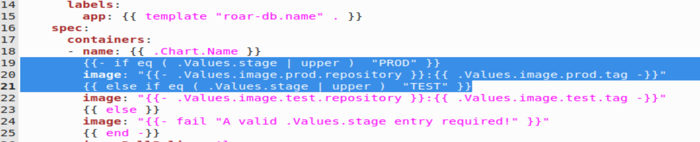

Or

$ ﻿meld charts/roar-db/templates/deployment.yaml ../extra/lab3-deployment2.yaml

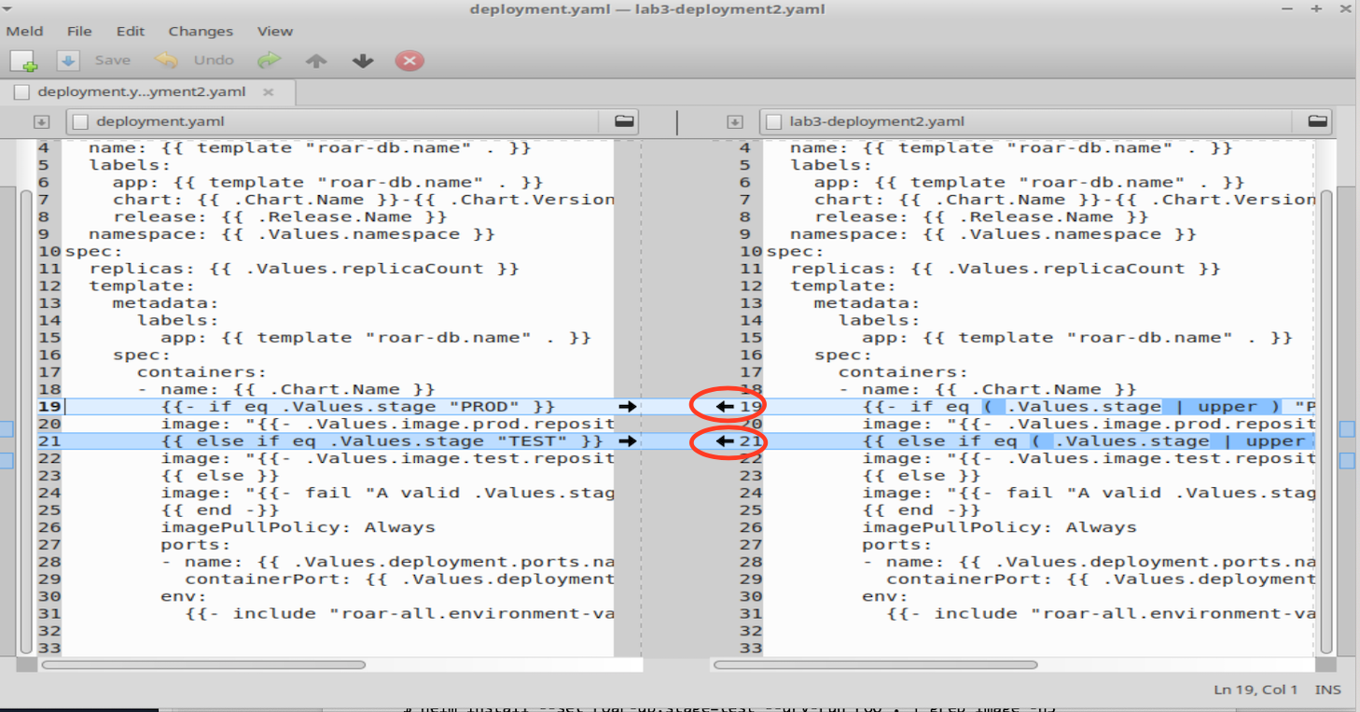

1. Save your changes and try running the command with the lower-case setting again. This time it should work.

$ helm install --set roar-db.stage=test --dry-run FOO . | grep image -n3

1. Finally let's try deploying a running test instance of our application and a running instance of the prod version of our application.

$ k create ns roar-prod

$ ﻿helm install -n roar-prod --set roar-db.stage=PROD roar-prod .

$ k create ns roar-test

﻿$ helm install -n roar-test --set roar-db.stage=TEST roar-test .

1. Now, you can get the NodePort for both versions. and open them in a browser to see the results.

$ k get svc -n roar-prod | grep web

$ k get svc -n roar-test | grep web

1. As a reminder, the port numbers that are > 30000 are the ones you want. You can open each of them in a browser at [http://localhost:<nodeport>/roar/](http://localhost:%3cnodeport%3e/roar/) and view the different instances.

**Lab 4 – Using Kustomize**

Purpose: In this lab, we’ll look at how to deploy into Kubernetes with Kustomize, an alternative approach to Helm.

1. Switch to the roar-kz subdirectory and use the tree command to look at the structure.

$ cd ~/hk-ws/roar-kz

$ tree

1. Notice how we have the base and overlay directories laid out and the occurrences of the *kustomization.yaml* files. Take a look at the kustomization.yaml files in the *base, overlays/stage,* and *overlays/prod* area to see what kind of changes these are layering on top of our specs. What is each one adding/modifying?

$ cat base/kustomization.yaml

$ cat overlays/stage/kustomization.yaml

$ cat overlays/prod/kustomization.yaml

1. Let’s do a kustomize build of the base area and capture the yaml that is produced for Kubernetes. Then let’s also do a kustomize build of the overlays/staging area and capture that output.

$ kz build base > base.out

$ kz build overlays/stage > stage.out

1. Let’s look at the difference between the kustomize build of base and the kustomize build of stage with the meld tool. What do you see as different?

$ meld base.out stage.out

**(NOTE: You do not need to click any arrows here or make any changes. This is just to look at differences.)**

Notice some of the changes in the database deployment spec now as shown in the excerpt below:

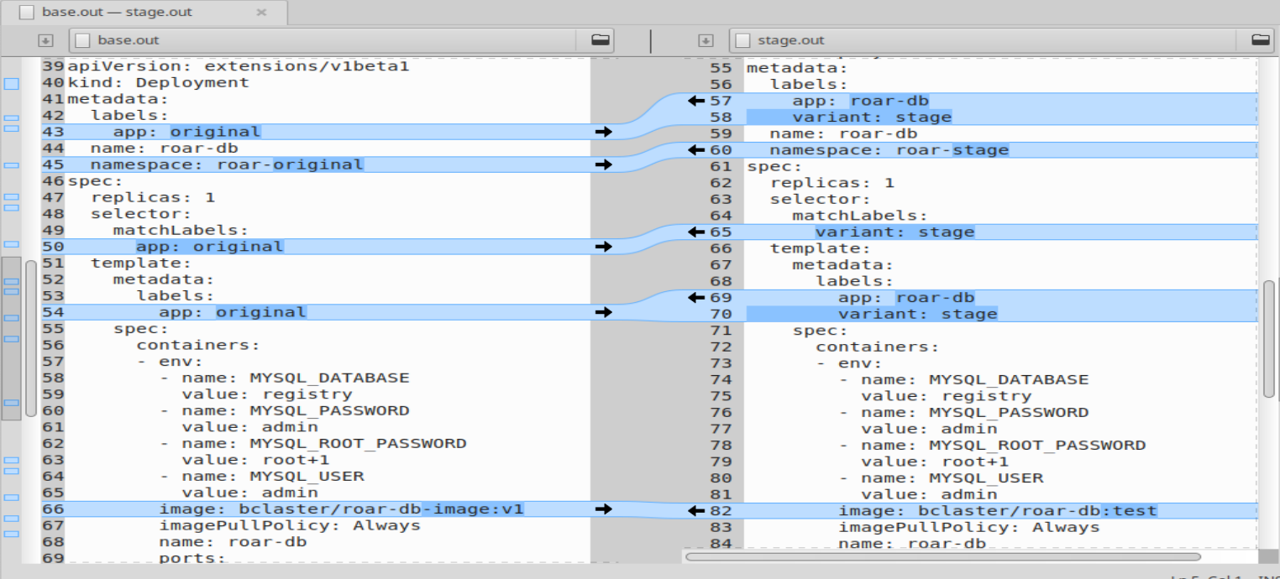

1. Now, let’s go ahead and apply the yaml produced from the kustomize build output to the cluster. We do this by simply piping it through Kubernetes apply.

$ kz build overlays/stage | k apply -f -

1. The preceding step should have created a new *roar-stage* namespace with a running instance of our app. Find the node for this as you have before and bring up the running instance.

$ kubectl -n roar-stage get svc

Note that the type of service for roar-web is “NodePort”. As before, this means we have a port open on the Kubernetes node that we can access the service through. Find the nodePort under the PORT(S) column and after the service port (8089) and before the “/TCP”. For example, if we have **8089:31789/TCP** in that column, then the actual nodePort we need is **31789**.

In the web browser, go to the url below, substituting in the nodePort from the step above for “<nodePort>”. You should see the running application with some test data.

[**http://localhost:<nodePort>/roar/**](http://localhost:%3cnodePort%3e/roar/)

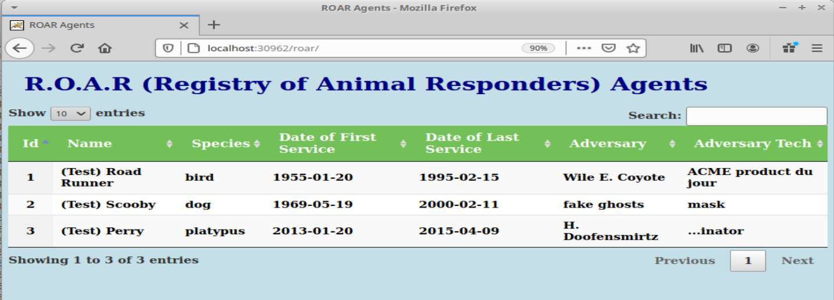

**Lab 5 – Working with Kustomize Generators**

Purpose: In this lab, we’ll look at how to work with a unique feature in Kustomize - generators - specifically - ConfigMapGenerators.

1. In the kustomization.yaml file we used for *overlays/stage*, we created a *ConfigMapGenerator* which made a config map with a hash. The hash acts like a key that the deployment knows about. Take a quick look at how the configmap generator is defined in our yaml file (at the bottom).

$ ﻿cat overlays/stage/kustomization.yaml

1. Then notice how it is rendered (in the staging area only) by looking at the top (right side) of the differences between the base and stage output.

$ meld base.out stage.out

**(NOTE: You do not need to click any arrows here or make any changes. This is just to look at differences.)**

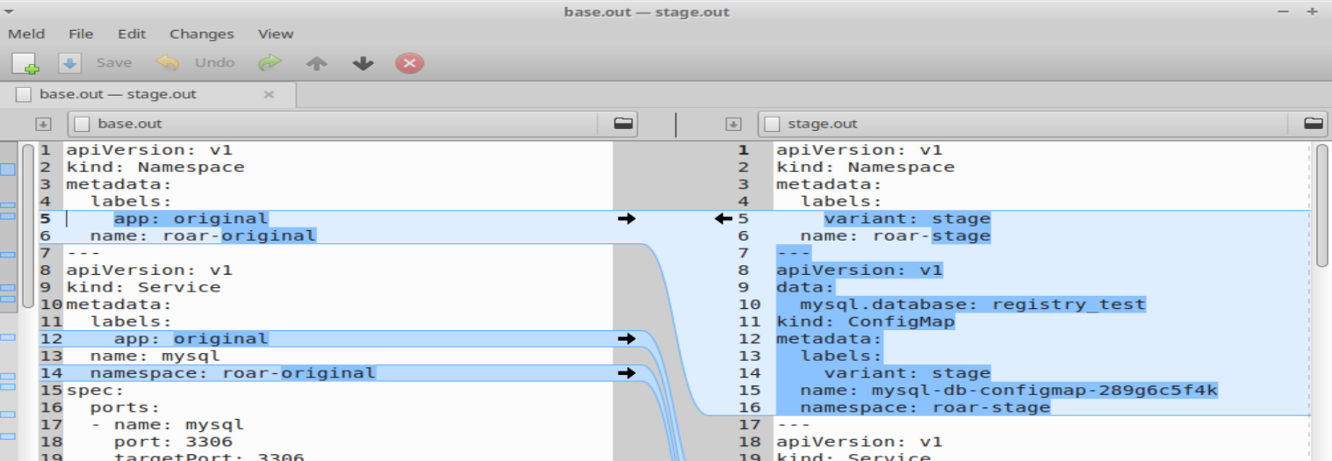

1. Notice the unique identifier value that's added on to it after "mysql-db-configmap". That's the generator part. Take a look at how this configmap is instantiated in the system.

$ kubectl describe configmap -n roar-stage

1. Now, let’s change the configmap by pointing to a different database for testing.

$ gedit overlays/stage/kustomization.yaml

**Then add a “2” onto the last line – change =registry_test to =registry_test2**

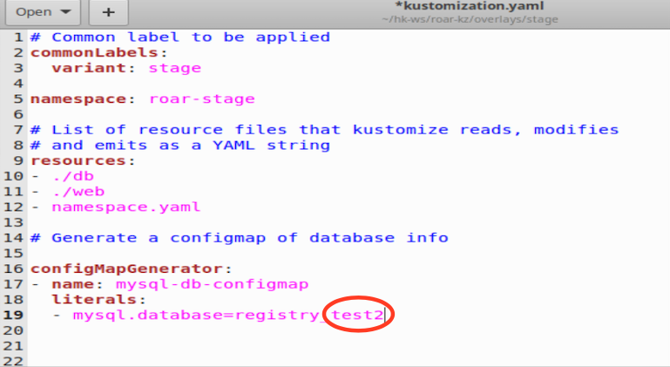

**Save your changes and close the editor.**

1. Now let’s see what the new generated configmap difference that our change made compared to the previous one. (Note the space followed by a dash at the end of the line.)

$ kz build overlays/stage | diff -c3 stage.out -

**Notice here that a new configmap was rendered AND the web deployment was updated as well.**

1. Build and apply the updated configmap.

$ kz build overlays/stage | k apply -f -

**Notice here that a new configmap was created AND the running web deployment was configured (updated) as well.**

1. OPTIONAL: Build and apply the kustomization from the prod area which will add in persistent storage.

Take a look at what’s mounted right now (should be nothing).

$ ls /mnt

Build and apply.

$ kz build overlays/prod | k apply -f -

Notice there’s a “pv” (persistent volume) object created as well as a “pv-claim” (persistent volume claim) object created.

You’ll be able to see the persistent storage at /mnt/data.

$ ls /mnt/data

END OF LAB